
Department of Computer Science and Engineering
Lab Report
Lab Report No : 01
Lab Report Name : Number Conversion.
Course Title : Numerical Methods Sessional
Course Code : CSE 226
Name : Fahim Faisal Pathan
ID : 1119033
Level : 2 Term: 2 Section: A Group: G2
Date of Submission. : 21/04/2026

Key Learning:
1. Recursion Basics: A function is called funRec(a/2). This needs a base case to stop: if(a==0) return
2. Divide and Conquer: Divide & Conquer is used to break a big problem into smaller, easier parts, solve them, and combine the results.
3. a/2 is used to continuously reduce the number.
4. a % 2 gives the binary digit (0 or 1).
5. Binary conversion works by repeated division by 2.
6. Printing after recursion gives correct order (MSB → LSB).
7. Recursion uses stack memory to store function calls.

Code Input:

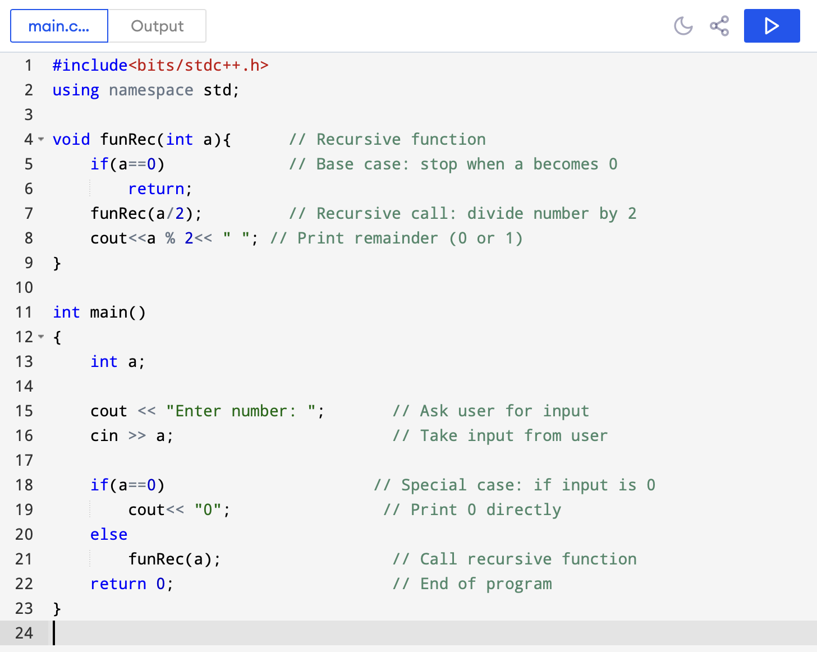

Code Output:

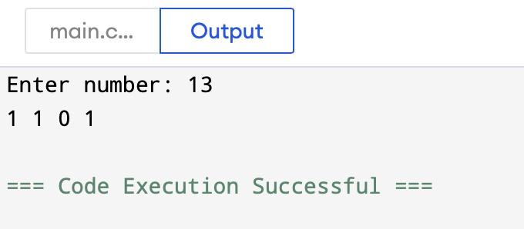

Result Analysis:
• The program converts a decimal number into binary using recursion.
• It repeatedly divides the number by 2 until it reaches the base case (0).
• The binary digits are printed during the return phase using the remainder (a % 2).
• A special condition handles input 0 by printing 0 directly.

